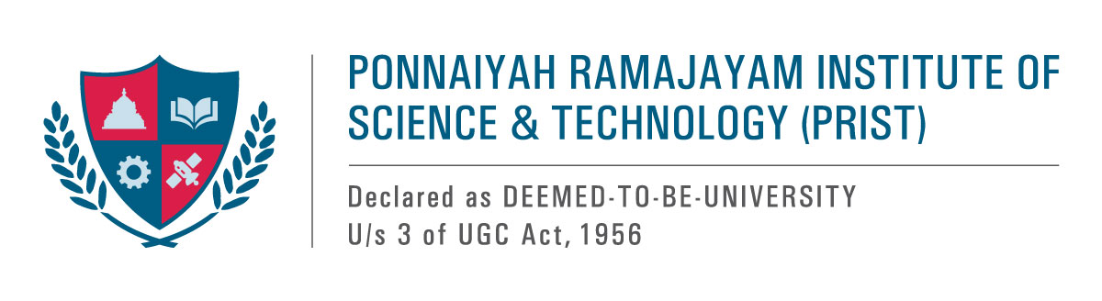

**Women’s Empowerment and Nutrition Programme**

The PRIST University, Thanjavur, hosted a profound awareness seminar on women's empowerment and nutrition programs conducted on 06.03.2025 in honor of International Women's Day. The esteemed Thanjavur Anu Hospital collaborated with the Thanjavur PRIST, a university campus, to host the seminar. Dr. Abdul Ghani Khan, the university registrar, inaugurated the seminar with great honor. The proceedings were gracefully led by the Chief Executive Officer, Dr. Venkata, HRD, who set a distinguished tone for the event.

Besides, the administrative director of Anu Hospital, Mrs. Tara Sivakumar, graced the occasion as a special guest, adding significant value to the discussions. Renowned nutrition specialist Ms. Priyadarshini delivered an enlightening discourse on the critical importance of nutrition for women while also providing comprehensive insights into effective food management strategies tailored for them.

Dr. R. Manikandan, the NSS Coordinator, expertly planned this significant event. More than 400 female students and professors attended the event in overwhelming numbers, and they all gained inspiration and priceless knowledge from this enlightening experience.

