NATIONAL UNITY DAY
The PRIST Deemed to be a university, the National Service Scheme conducted and observed National Unity Day at Vallam-Thanjavur for the purpose of commemorating the birth anniversary of freedom fighter Sardar Vallabhbhai Patel. However, volunteers from NSS performed several programs to emphasize the importance of national unity. Finally, every volunteer for the NSS participated in the oath-taking ceremony to ensure national unity.
“ NATIONAL UNITY DAY”
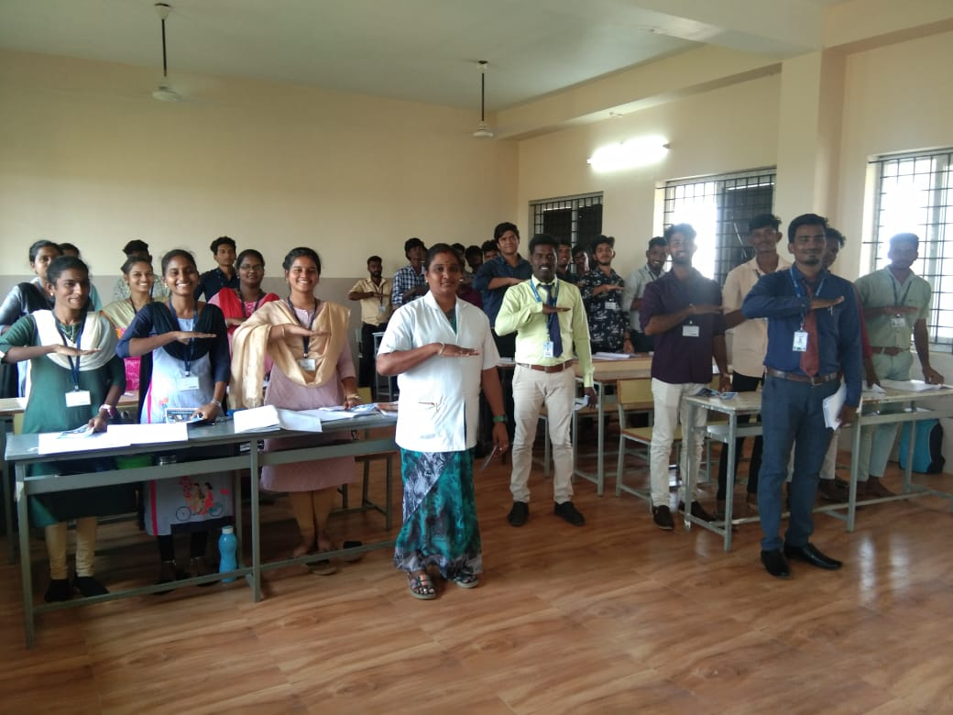

Event Name: National Unity Day Place: PRIST Deemed to be University
Date of the Event: 30.10.2024 Map: Latitud 10.72102°; Longitude:
e: 79.04313°

Volunteers took pledge

