World Heart Day - Walkathon Report.

World Heart Day serves as a potent reminder of the indispensable function that this organ plays in our general health. It's a chance to encourage and support one another in addition to focusing on heart health. In the business world, where deadlines, goals, and pressures can occasionally take precedence over our health, it is imperative that we acknowledge this day.

On September 29, 2024, PRIST University, NSS Cell, and Meenakshi Hospital Thanjavur jointly conducted health walks and held a 3-kilometer walkathon to raise awareness of heart disease. The walkathon campaignwas organized by the NSS Coordinator along with invited Chief Deputy Inspector General of Police Thiru. Ziaul Haque I.P.S. in honor of World Heart Day. Participants gave tips for maintaining a healthy heart, reinforcing the importance of lifestyle choices in preventing heart disease, and overall, the function has been completed successfully, along with the valuable participants.

**Glimpses of the program**

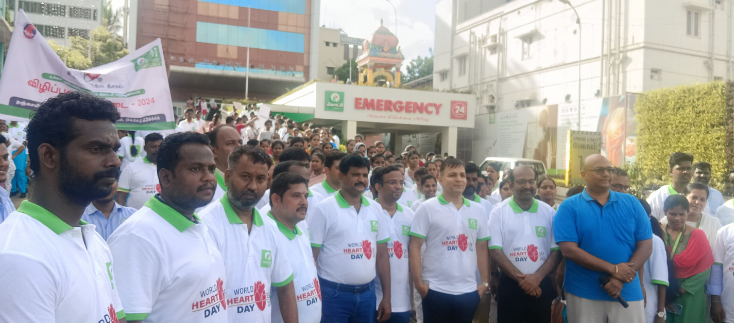

**The walkathon was attended by our NSS coordinator along with Deputy Inspector General of Police Thiru.Ziaul Haque I.P.S.**

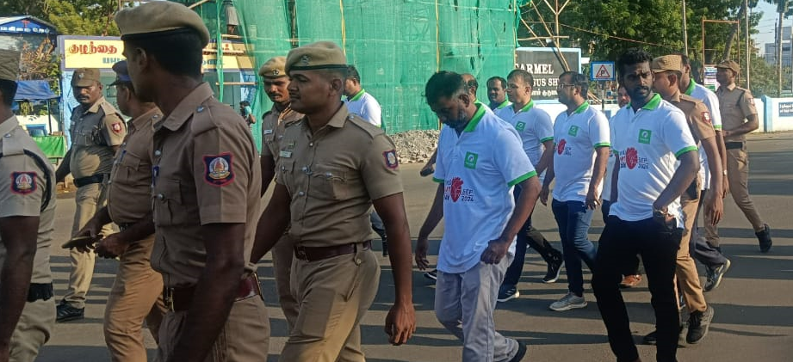

**PRIST University staff members and NSS volunteers actively participated in the walkathon.**

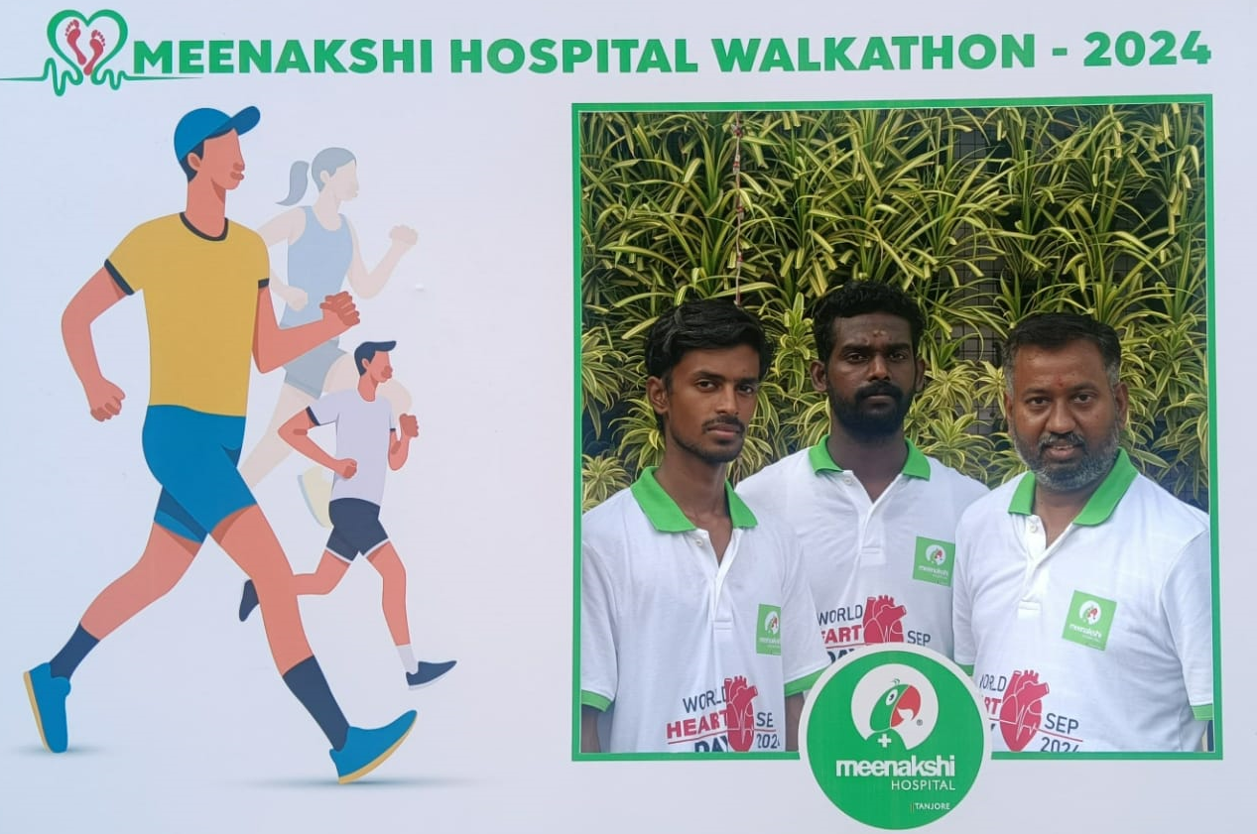

**Glimpses of the walkathon photo point.**

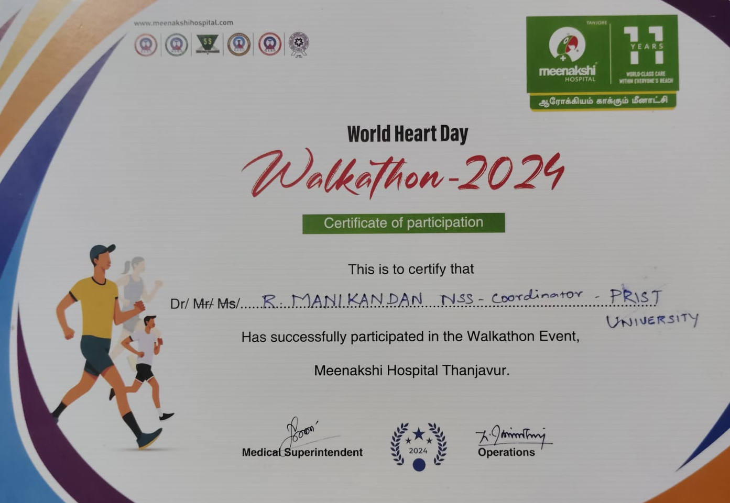

**Sample Certificate— that of Coordinator, NSS.**