**WOMEN’S EMPOWERMENT PROGRAMME**

In connection with the International Women's Day celebrations, which were held at Thanjavur PRIST Deemed to be University. The District Social Welfare Officer, Mrs. R.T. Latha, participated as the special guest. In her speech, she elaborated on the various social problems faced by women in society today and the solutions to them. She also discussed the history of Women's Day and the excellent contribution of women in the family and society. She also briefed the students on the government's various special programs for women and their needs. The event also featured various cultural programs, culminating in prizes for the students. Overall, more than 500 professors and students participated in the event.

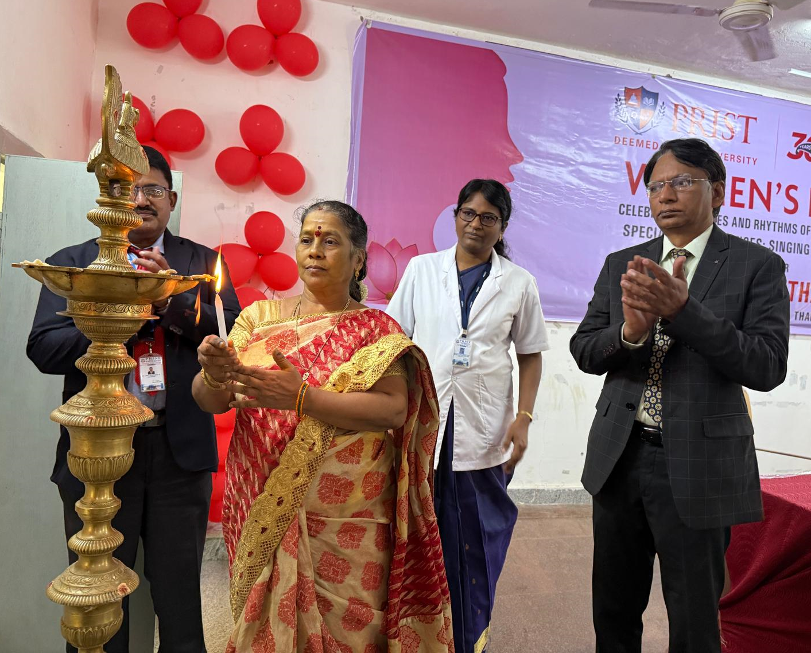

**Mrs. R.T. Latha, the District Social Welfare Officer, is lighting the sacred lamp.**

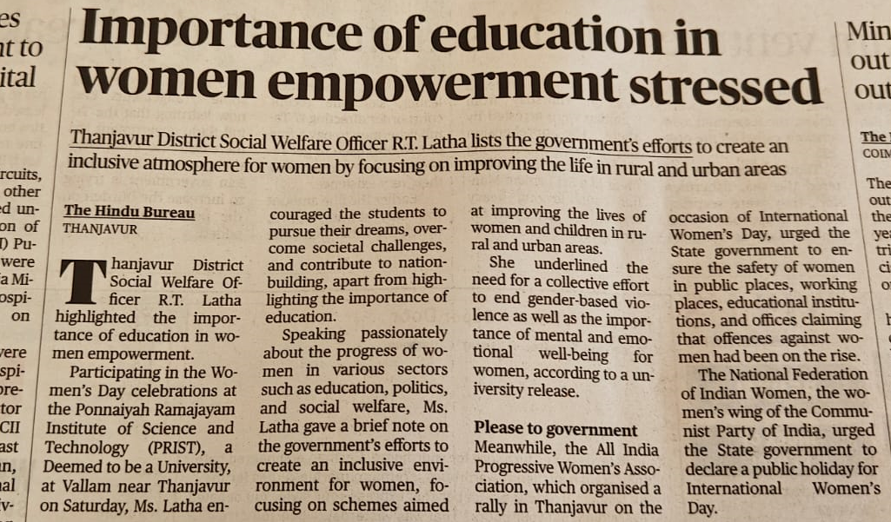

**The Hindu English Daily published the news.**

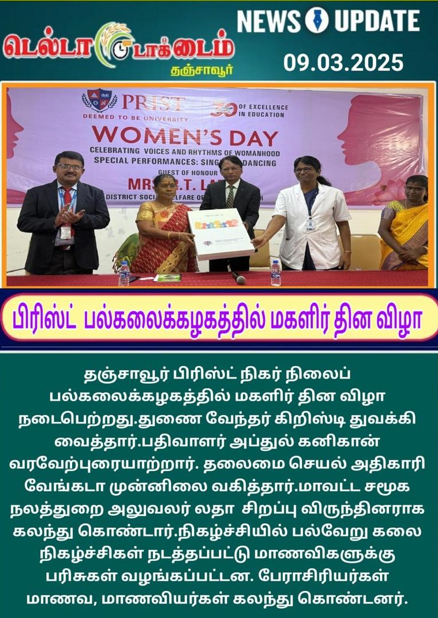

**News published in the newspaper**