**ROAD SAFETY PROGRAMME**

The PRIST university NSS team integrated with district administration and organized a road rally dated 25.01.2025 to spread awareness about road safety and responsible driving under the aegis of the “Road Safety Club.” The rally witnessed enthusiastic participation from NSS volunteers and the public. The event aimed to raise awareness about road safety issues, educate participants and onlookers on safe practices, and promote a sense of responsibility among the community members. The primary objective of the Road Safety Rally was to engage the community actively, emphasizing the importance of following traffic rules, responsible driving, and adopting safety measures to reduce road accidents and fatalities. The rally commenced at 10:00 am at the Collector's office, Thanjavur. The honorable district collector flagged off the rally. Some of the key messages highlighted were obeying speed limits, avoiding drunk driving, wearing helmets and seatbelts, avoiding mobile phone use while driving, and following traffic rules. The rally for road safety awareness helped spread consciousness about responsible road behavior in an impactful manner. The NSS volunteers of PRIST Deemed to be University enthusiastically participated in the event.

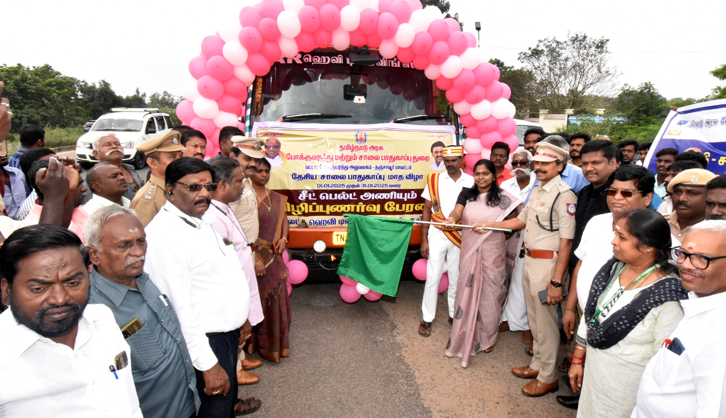

**Honorable District Collector flagged off the rally**