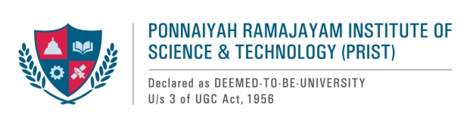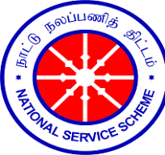

**REPORT ON ANTI-DRUG AWARENESS CAMPAIGN**

1. **Name of the Activity**  : Anti-Drug Awareness Week
2. **Date of Activity** : 26-11-2024
3. **Organized by/Name of the committee** : PRIST--NSS UNIT

**Activity objectives**

1. Empower students to make informed decisions related to the use of alcohol and other drugs.

2. Emphasize an awareness of choice, personal responsibility, and understanding of consequences in deciding to use alcohol and other drugs.

3. Encourage the campus community to prevent alcohol- and drug-related incidents.

**Report:**

Under the auspices of NSS, our university held an anti-drug awareness week. Our NSS students who volunteered for the event participated in several activities, including painting, writing essays, and a slogan competition with the topic "Say No to Drugs." Our NSS program officer, Dr.Manikandan, displayed that poster on the university notice board to raise awareness among the students. In conclusion, Dr. T.V. Christy, the Honorable Vice Chancellor of PRIST University, stated that this program has a bigger duty to raise awareness of this issue, having inspired the aforementioned. The students presented awards to the winners. "Life is a priceless gift from God. You should avoid drug abuse and keep it proper. You should educate your friends about the issue as well,’ he said’.

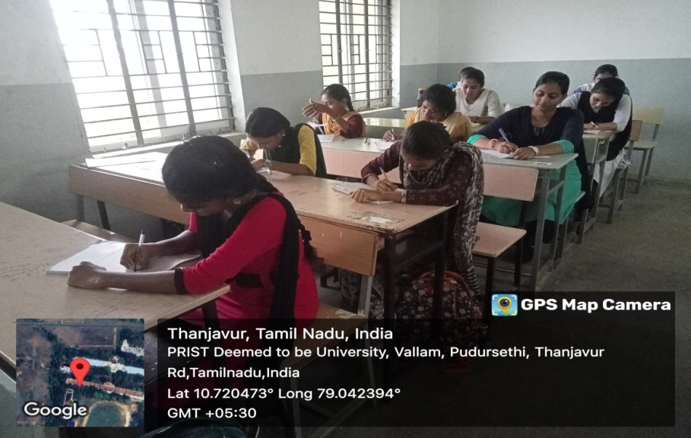**Glimpses of the program**

**Students are writing essays on "Say No to Drugs."**

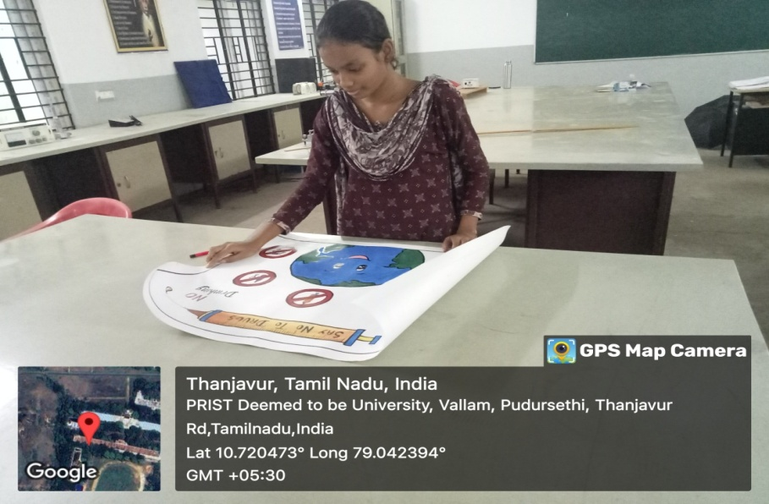

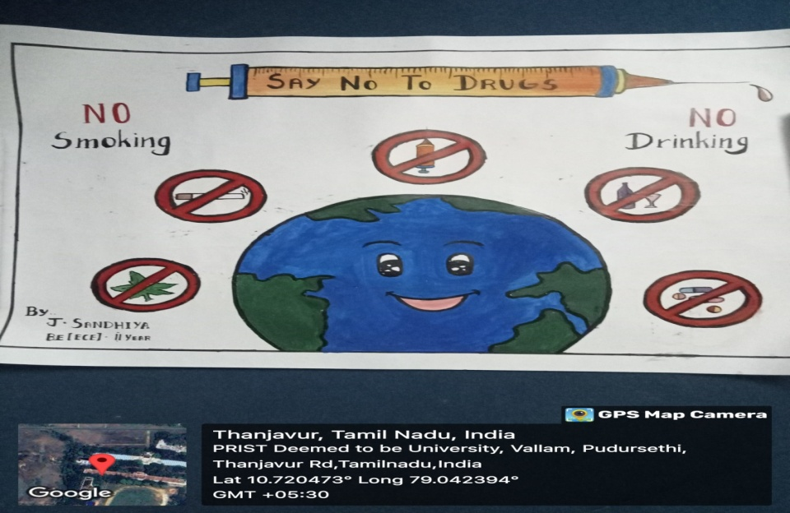

**Students painted with the topic "Say No to Drugs."**

