**General Health Camp for under Underprivileged Rural people**

The National Service Scheme PRIST Deemed to be a university, Thanjavur conducted a general health camp on 28.03.2025 at Kuruvadipatti village with the support of Meenakshi Hospital Thanjavur. The health camp's goals were to raise people's awareness of general health issues, offer general healthcare services, and offer them guidance on basic hygiene and medical care. People who ranged in age to elderly suffered from conditions like diabetes, low blood pressure, hypertension, hypotension, and obesity. The elderly were experiencing various musculoskeletal issues, including pain in their knees, backs, and necks, and most of the female population was suffering from obesity and being overweight.

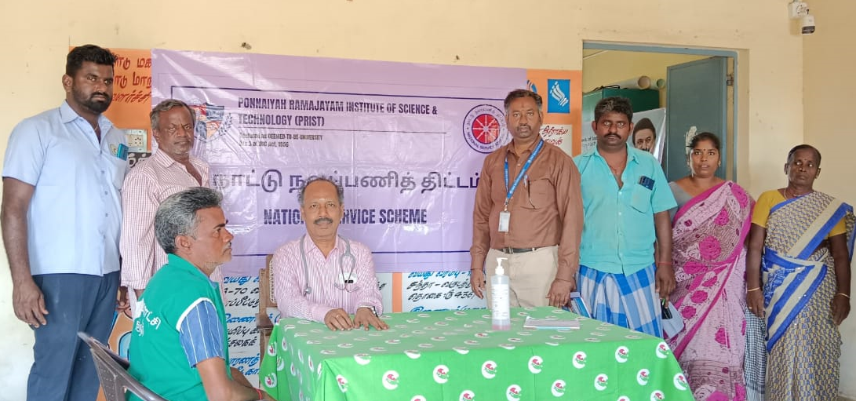

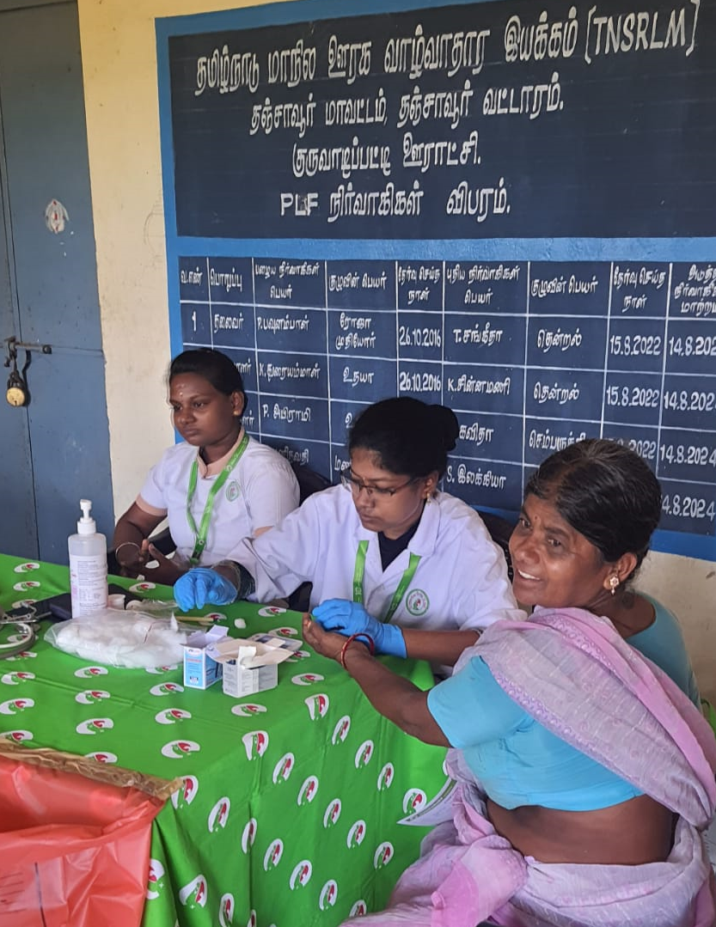

**Medical team examine the village people**