**Free Medical camp for School students**

PRIST University organized the health camp on 27th March 2025 at Government School, Vallam, coordinated by NSS Cell, PRIST, along with Government Hospital Vallam. The camp aimed to provide essential health checkups and awareness programs to the local community. Medical professionals offered services such as blood pressure screenings, glucose testing, and educational sessions on preventive health measures. The faculty guided the students promptly and carried out the following tasks during the program's general health check-up.

**The List of Health Check-up**

* Hemoglobin estimation
* BMI Checking
* Dental Checking
* Pamphlet distribution
* Mass Awareness Program

**Feedback**

Everyone who witnessed the event appreciated the program's effectiveness at the end, as it cleared the doubts raised by the public. We received feedback from the public stating that the program was good, informative, and raised awareness.

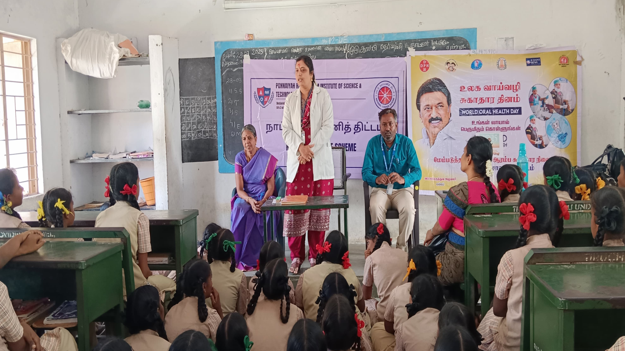

**Dr. M.R. Abirami from Government Hospital Vallam gave the advice to students**.