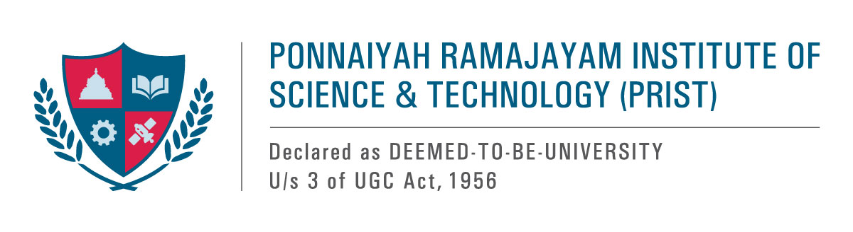

**“NANO FOREST” SEMINAR**

The PRIST University conducted the National Forest Day seminar on 21/03/2025, led by the Chief Executive Officer, Dr. Venkata, PRIST University, jointly with Mrs.Vidya, the Joint Director of Agriculture for the Thanjavur region, as the special guest.

During her address, she highlighted the alarming reduction in forest cover and its adverse effects on biodiversity. She stressed the significance of afforestation and forest preservation. She also commended PRIST University for its efforts in establishing a “Nano Forest” and a “Bird Sanctuary” spanning two acres.

The seminar saw active participation from over 250 students. Moreover, she encouraged everyone to plant a sapling every Friday as a step toward environmental sustainability. Following her speech, both faculty members and students took a pledge to uphold this initiative.

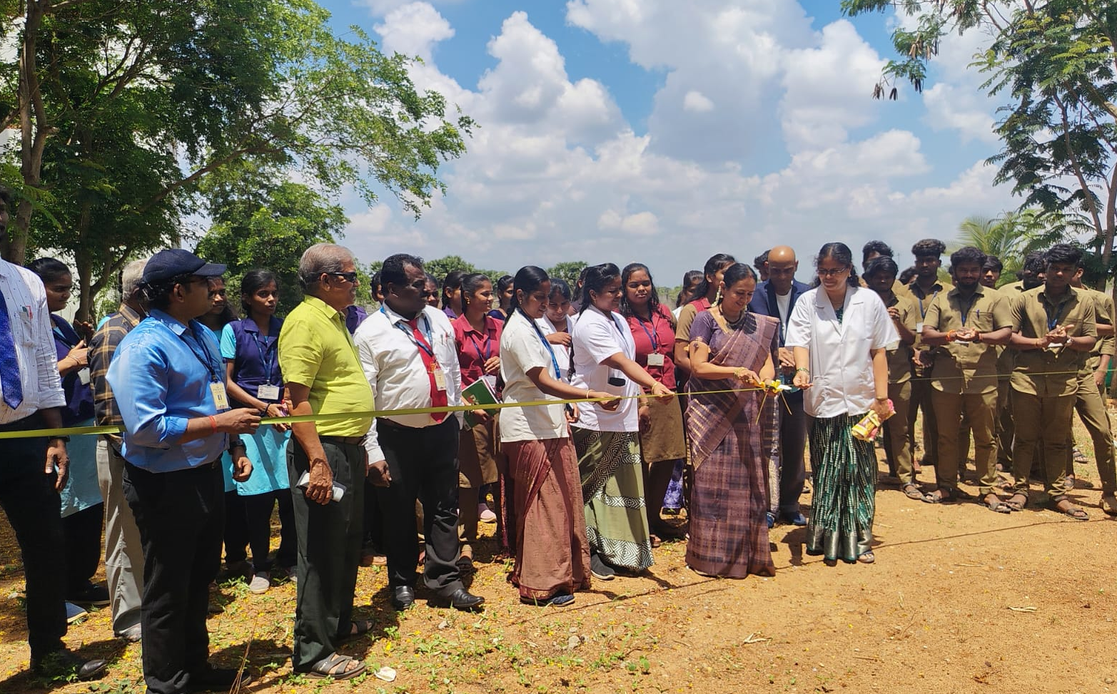

**The Joint Director of Agriculture, Thanjavur, cut the green ribbon during the inauguration of Nano Forests on the eve of the International Day of Forests.**

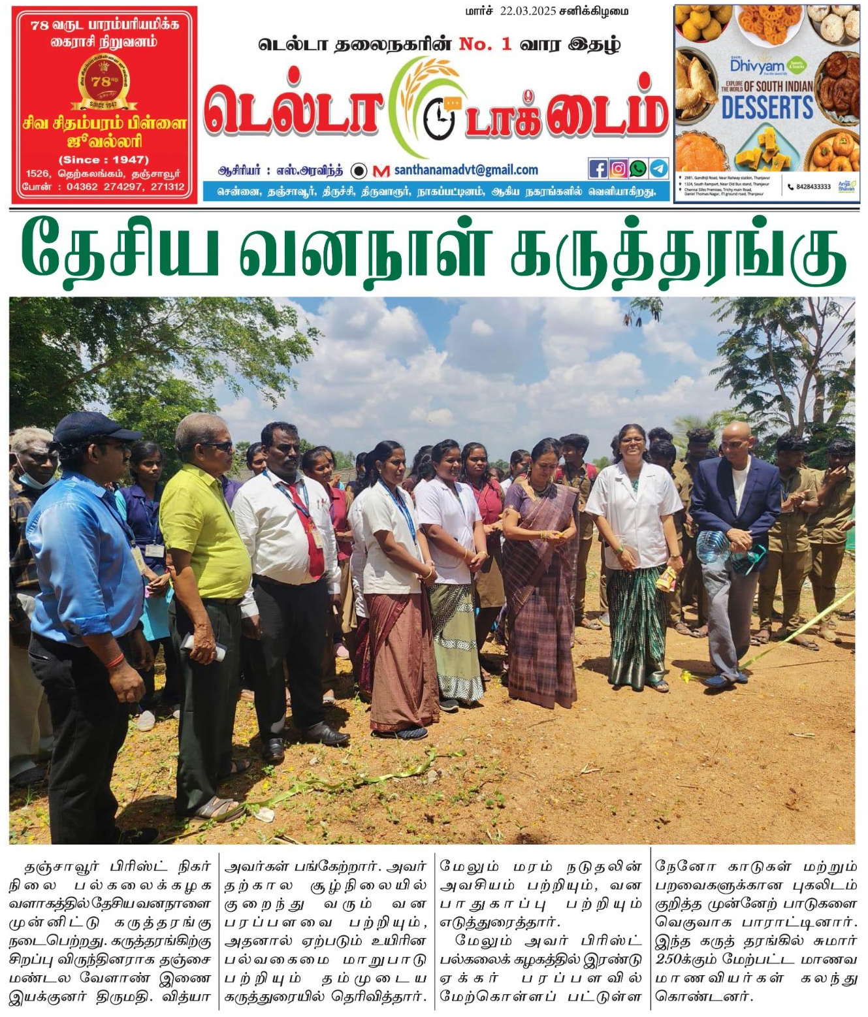

The news was published in the Daily Thanthi.