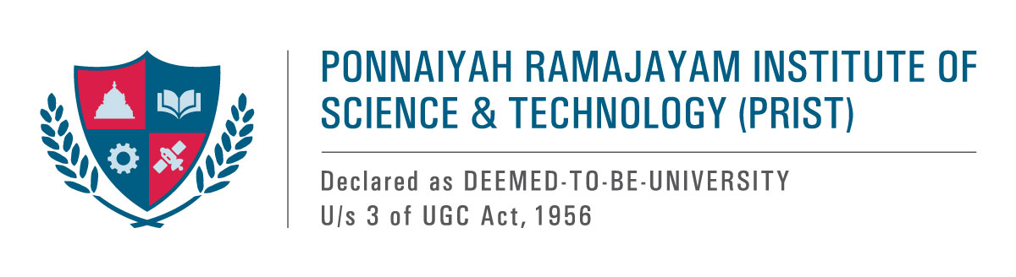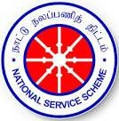

**Drug Awareness Rally - Report**

As part of the extension activity, the NSS Cell of PRIST University organized a drug awareness rally in collaboration with the District Health Department in Thanjavur.

**Aim and Objectives**

The goal is to raise awareness about drug abuse.

The aim is to strengthen action and cooperation in achieving the goal of a world free of drug abuse.

On November 23, 2024, PRIST deemed it appropriate for the university's personnel and students to stage a sizable rally from Thanjavur New Bus Stand and host an awareness rally for a world free of drug misuse. We organized these rally activities to commemorate the "Against Drug Abuse and Illicit Trafficking" event. These initiatives aimed to empower the community with knowledge and resources to combat the rising issue of substance abuse effectively. Our university's NSS Cell planned to take over the event in collaboration with the Thanjavur District Health Department. At most, the rally attracted about 300 participants.

Invited chief guest **Mr. Ganesh Kumar, district superintendent of police**, Thanjavur, flagged off the event. **Mr. Singaravelu, District Health Inspector, Thanjavur,** also participated in the event. **Hon. Vice-Chancellor Dr. T.V. Christy** delivered a keynote message titled “Together, let us amplify our efforts to combat the global drug problem, guided by the principles of science, compassion, and solidarity." Through collective action and a commitment to evidence-based solutions, we can create a world where individuals are empowered to lead healthy, fulfilling lives.” This program was planned to raise awareness of the growing threat of drug addiction among young people. The march began at the Thanjavur New Bus Stand and proceeded down all major thoroughfares until it reached Bharath College. The program increased people's awareness of the health issues associated with drug abuse.

**CONCLUSION:**

Everyone who witnessed the event greatly appreciated the program, which was effective in clearing the doubts raised by the public. Finally, we received feedback from the public stating that the program was good, informative, and effective in raising awareness.

**Glimpses of the program**

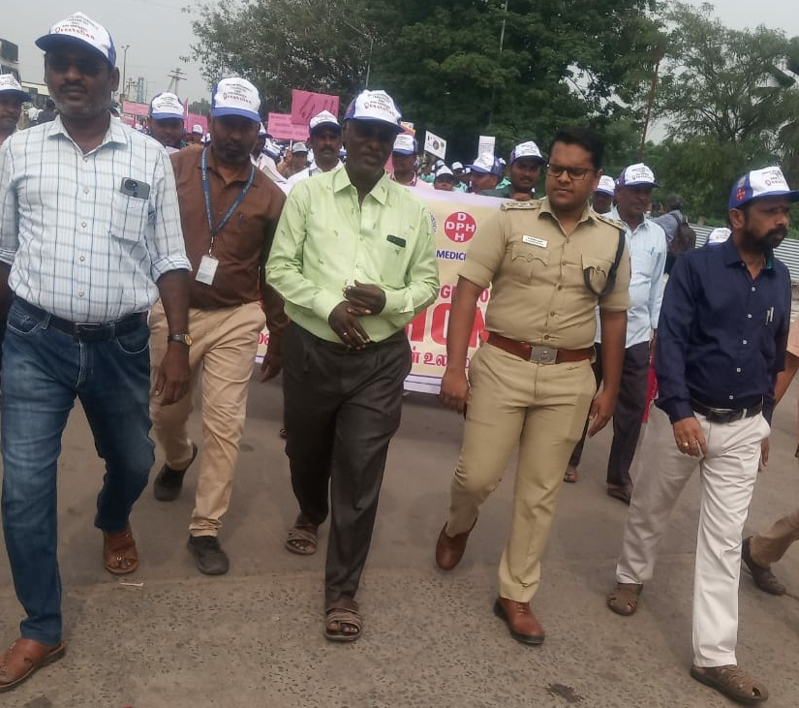

**Mr. Ganesh Kumar, District Superintendent of Police, Thanjavur, and Mr. Singaravelu, District Health Inspector, Thanjavur, NSS Coordinator, participated in the rally.**

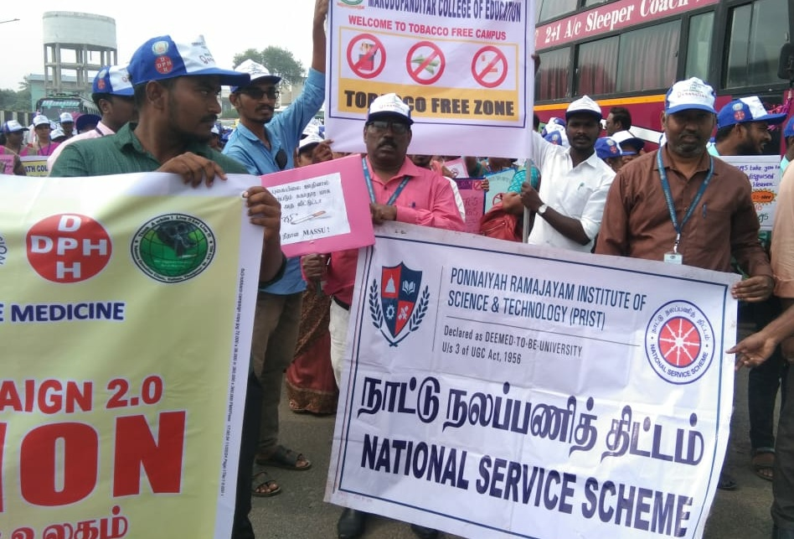

**University staff members hold the awareness slogans against drugs during the rally.**

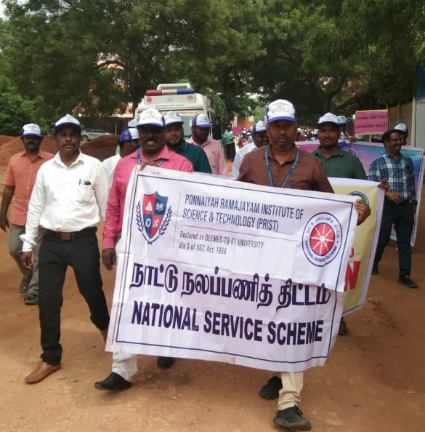

**Our university staff members and NSS volunteers actively participated in the rally**.

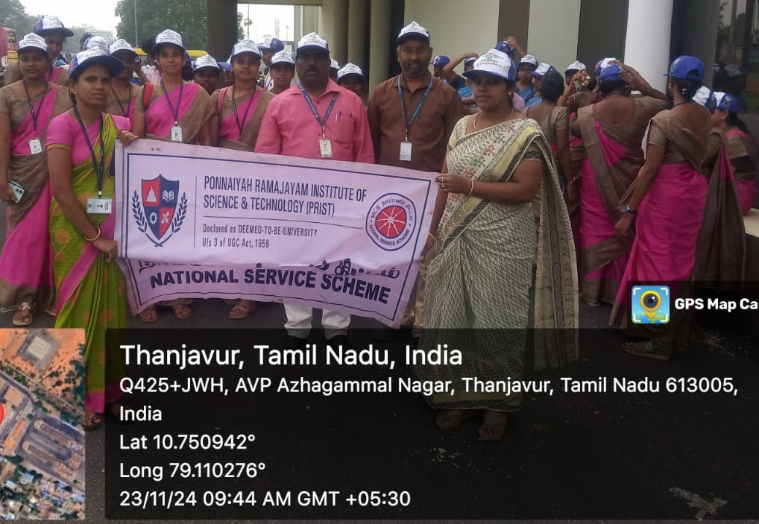

**A section of NSS volunteers actively participated in the rally.**