**Diabetic awareness Camp on 14.11.2024**

Date of the Event: 14-11-2024

Name of the Event: Diabetes Checkup Camp

Venue: PRIST Seminar Hall.

No. of staff participants: 250

**A Report on the Diabetes Checkup Camp** on **World Diabetes Day**

Every year, November 14th is celebrated as World Diabetes Day. World Diabetes Day (WDD) was created in 1991 by IDF and the World Health Organization in response to growing concerns about the escalating health threat posed by diabetes. To achieve this, PRIST, the deemed-to-be University NSS Cell, along with Kamatchi Hospital Thanjavur, conducted a “Diabetes Check-up Camp” on 14th November 2024, on the occasion of “World Diabetes Day.” All the faculty, staff, and workers have been part of this program.

In 2006, the United Nations passed Resolution 61/225, making World Diabetes Day an official United Nations Day. Every year, we mark it on 14 November, the birthday of Sir Frederick Banting, who co-discovered insulin with Charles Best in 1922. WDD is the world’s largest diabetes awareness campaign, reaching a global audience of over 1 billion people in more than 160 countries. The campaign raises awareness about issues that are crucial to the diabetes community and maintains diabetes's prominent position in public and political discourse.

Dr. B. Kesava Moorthy, senior cardiologist from Meenakshi Hospital; Dr. G. Karthikeyan, senior dialectologist from Kamatchi Hospital, Thanjavur; and Dr. Killivalavan, senior dialectologist from Dr. Mohan's Diabetic Centre, contributed to the camp.

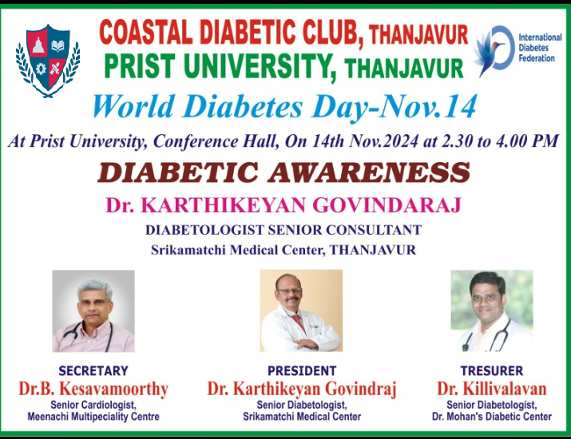

**Doctors' Team Examines Our Staff's Health**