“Cardiopulmonary Resuscitation (CPR) Awareness Program,”
In February 2025, NSS Cell PRIST Deemed to be University hosted a significant event, the “Cardiopulmonary Resuscitation (CPR) Awareness Programme,” in collaboration with the Anu Hospital Thanjavur. Dr. M. Abdul Ghani Khan, the registrar, began the program. The program, conducted offline, aimed to train individuals in life-saving CPR techniques, focusing on chest compressions and rescue breaths, with the primary objective of providing immediate assistance to those experiencing cardiac arrest until professional help arrives.
The event witnessed the participation of 200 faculty members. The program, aligned with the Anu Hospital Thanjavur initiative, addressed the rising cases of heart attacks nationwide. With a 12.5% increase in deaths due to cardiac arrests from 2021 to 2024, the CPR training sought to create a more informed and prepared society capable of responding to medical emergencies effectively.
The highlights of the program included early intervention strategies, imparting Basic Life Support (BLS) skills, AED training, team coordination in resuscitation efforts, awareness of the Chain of Survival, and legal and ethical considerations in providing CPR. The initiative aimed to adapt CPR training to various settings, ensuring participants could apply their skills in diverse situations.
Dr. R.V. Sivakumar, the senior cardiologist, delivered a keynote address emphasizing the importance of cardiopulmonary resuscitation in patient care. His words resonated with the audience, highlighting the benefits of attending the training program. These benefits included acquiring lifesaving skills, immediate response capabilities, confidence in emergency situations, community resilience, team coordination, understanding AED usage, child and infant CPR skills, legal and ethical awareness, and certification.
The CPR Awareness Program at PRIST, which was supposed to be a university, proved to be a pivotal initiative in aligning with national efforts to combat the increasing instances of cardiac arrests. By equipping participants with essential CPR skills, the program aimed to contribute to a more resilient and responsive community in medical emergencies. The engagement of both students and faculty underscored the importance of widespread CPR training in saving lives and promoting a culture of preparedness.

Photos: The Registrar PRIST University, Honoured Dr. Sivakumar the senior cardiologist Anu Hospital

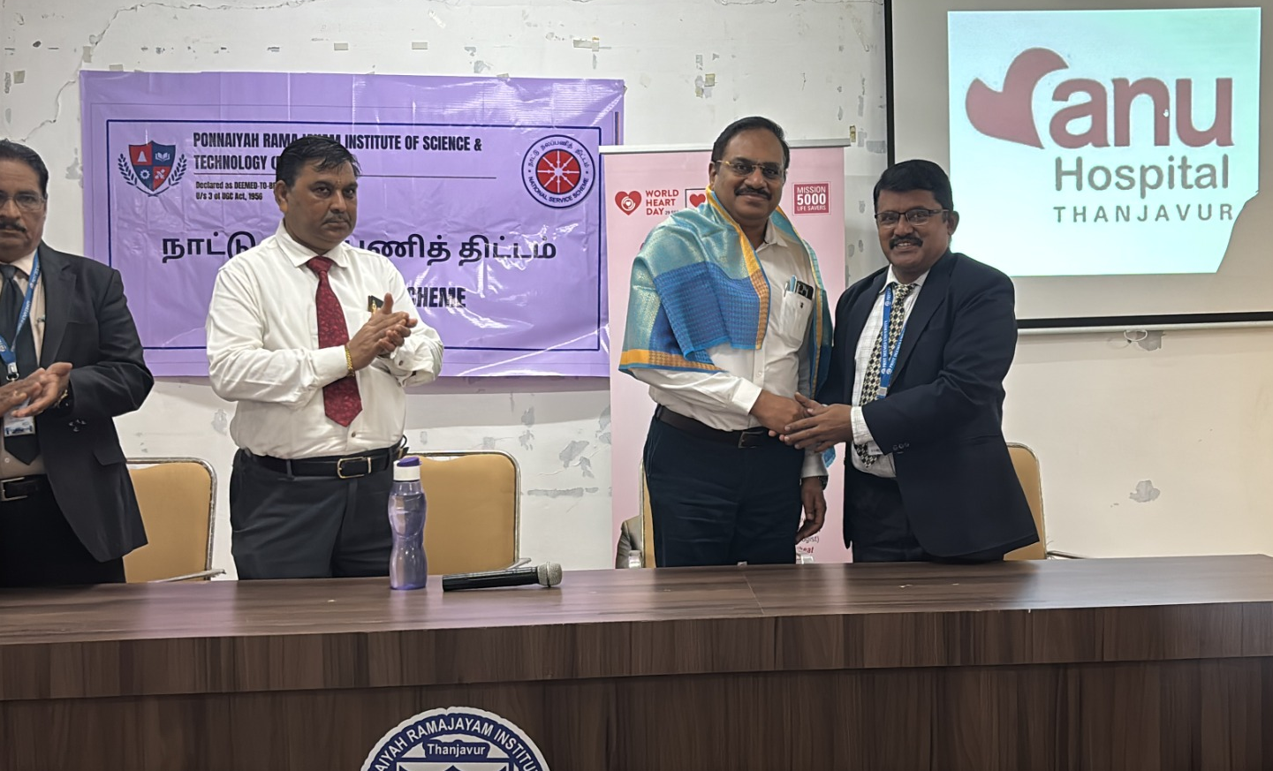
The expert gave the training about CPR

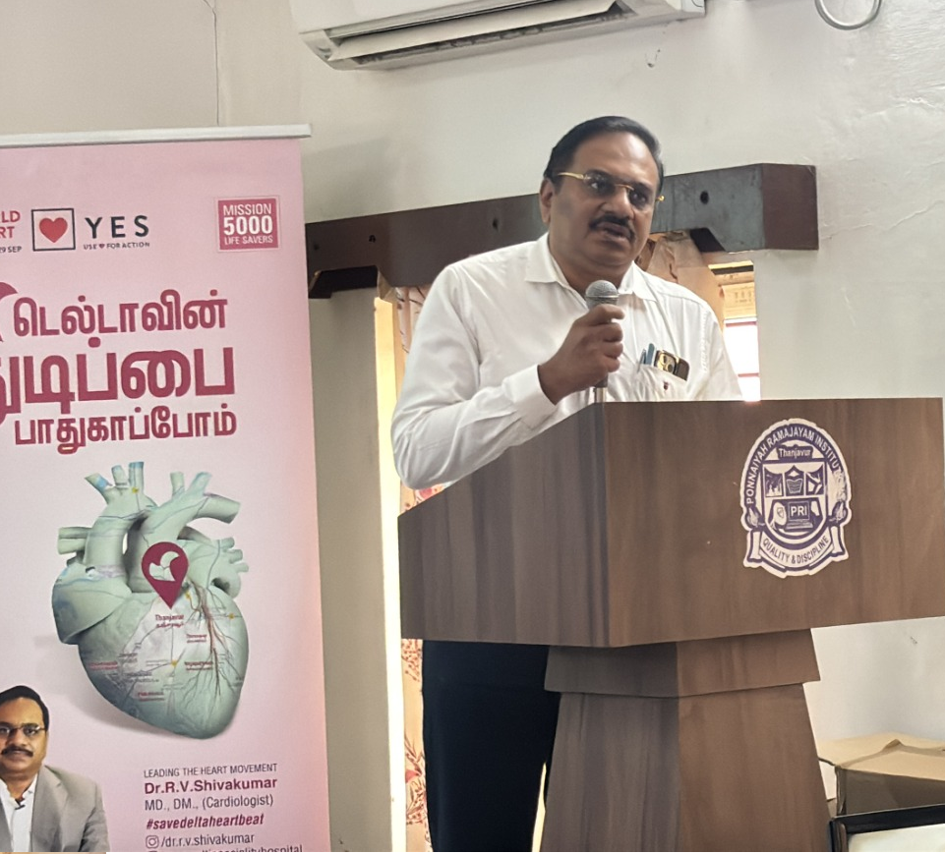
Dr. R.V.Sivakumar the senior cardiologist Anu Hospital Gave the Special address
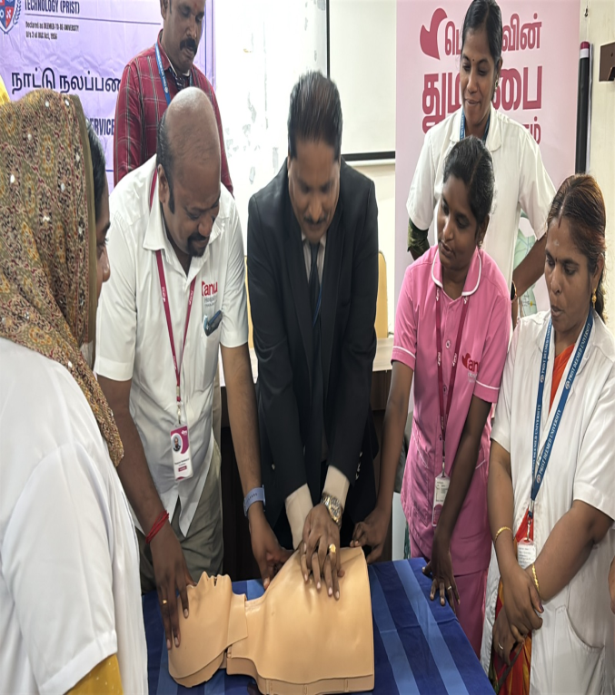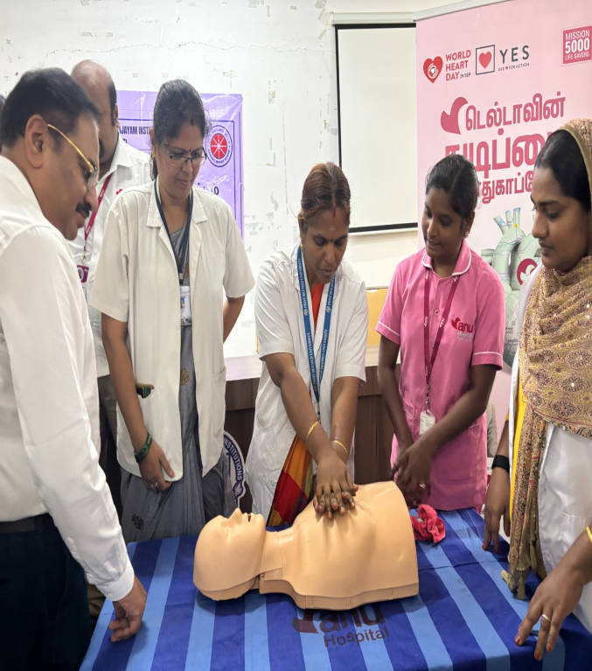
Our dean and faculty members took CPR training.

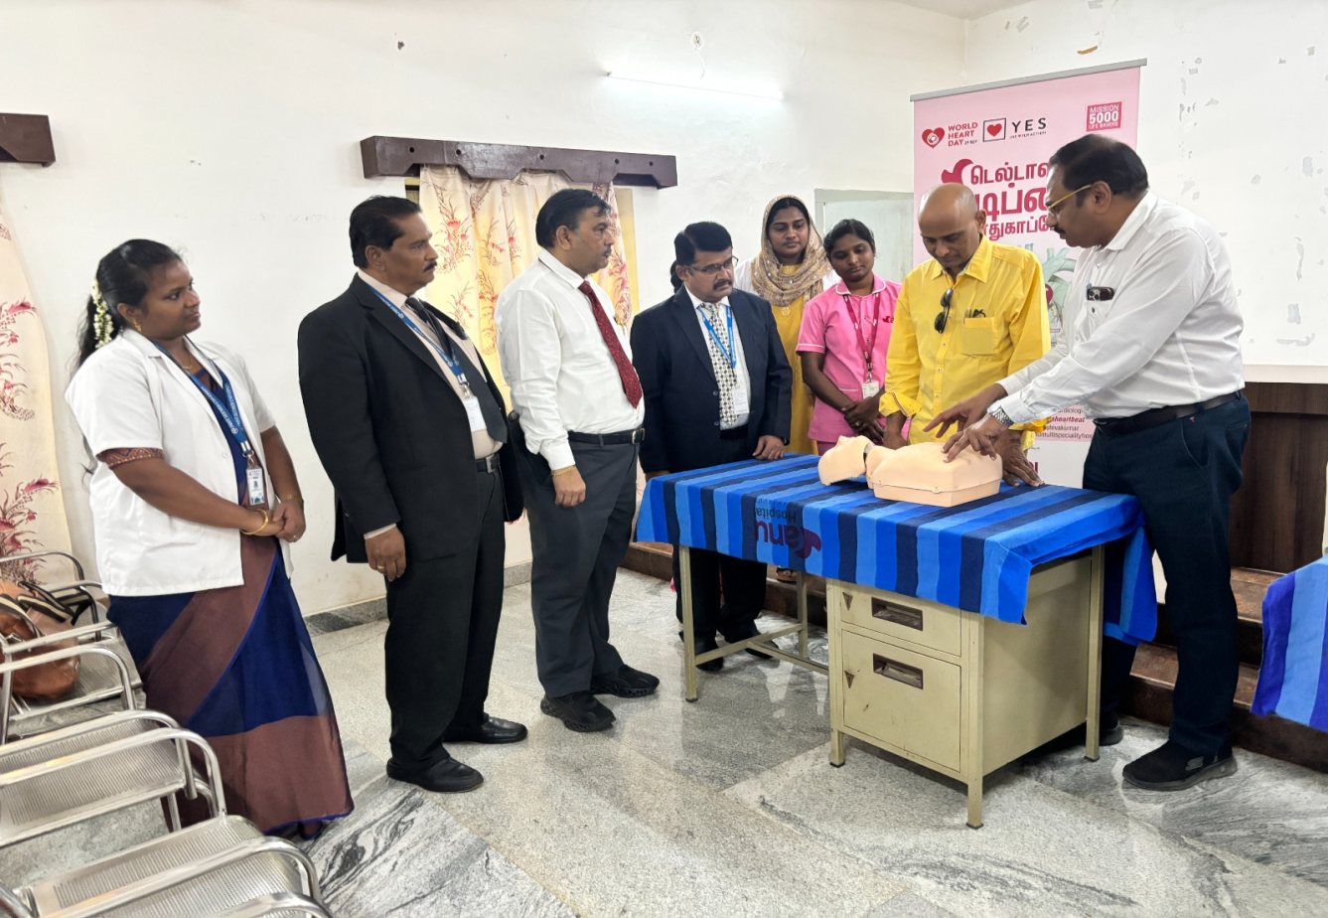
Our CEO, Dr.Venkata HRD Discuss with Dr. R.V. Sivakumar, the senior cardiologist at Anu Hospital.
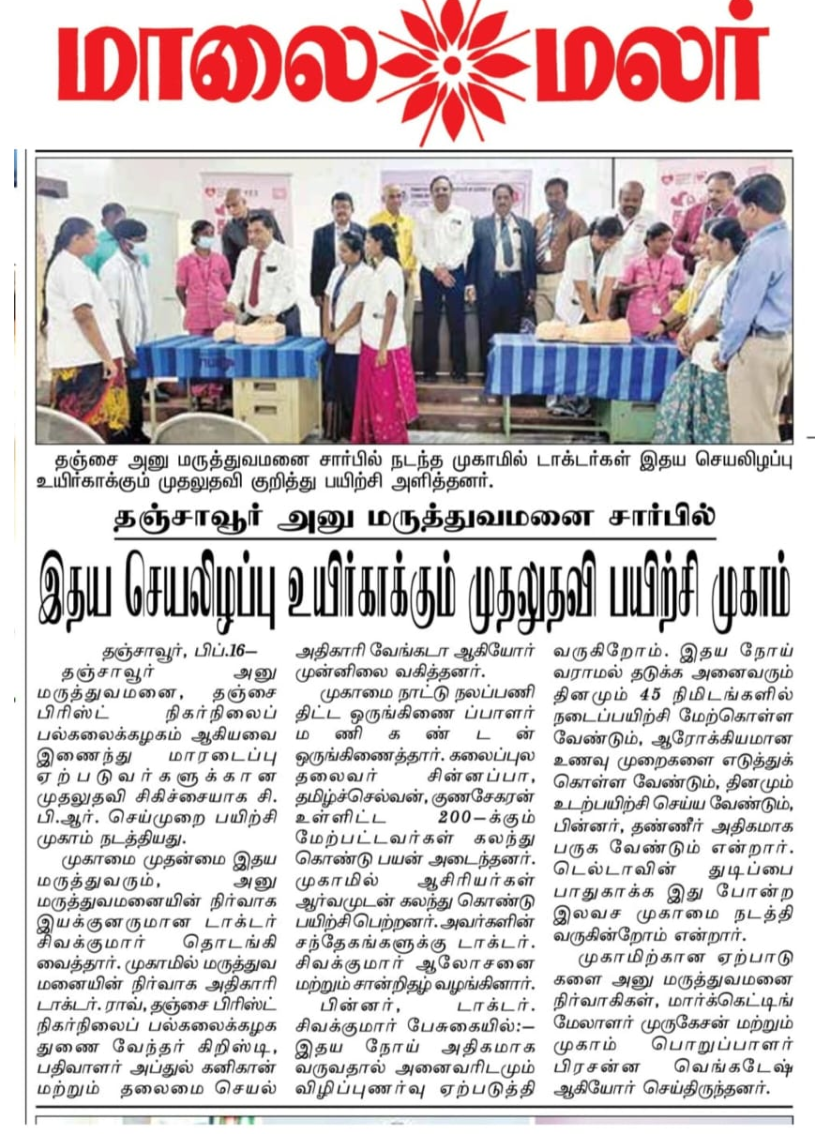
The event was published in a Tamil daily newspaper.

