World Heart Day - Walkathon Report.

World Heart Day serves as a potent reminder of the indispensable function that this organ plays in our general health.It's a chance to encourage and support one another in addition to focusing on heart health. In the business world, where deadlines, goals, and pressures can occasionally take precedence over our health, it is imperative that we acknowledge this day.

On September 29, 2024, PRIST NSS Cell and Meenakshi Hospital Thanjavur held health walks, often known as Walkathon campaigns, in honor of World Heart Day.

PRIST NSS Cell and Meenakshi Hospital Thanjavur held a 3-kilometer walkathon to raise awareness of heart disease. The walkathon started at Bishop Sundaram Campus and ended at Meenakshi Hospital Thanjavur.

The event was flagged off by Deputy Inspector General of Police Thiru.Ziaul Haque I.P.S.

Doctors explained that heart diseases can lead to various health issues, which aren’t just caused by alcohol consumption but also by obesity and high-fat diets, and it’s crucial to priorities heart health to avoid heart failure and potential transplant surgery.

"On this special day, let's come together to promote heart-healthy habits and inspire others to take better care of their precious hearts," said Hon. Vice-Chancellor Dr. T.V. Christy in his keynote address.

Everyone who attended the event expressed gratitude for the program, which was successful in dispelling public concerns. The public gave us feedback, saying the show was good, more educational, and raised awareness.

**Glimpses of the program**

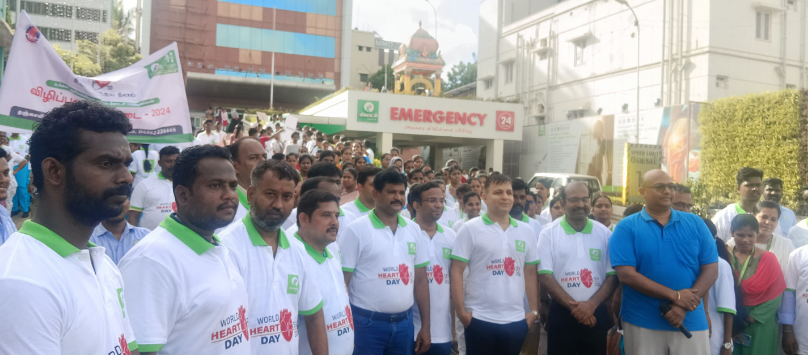

**The Walkathon was attended by our NSS Coordinator along with Deputy Inspector General of Police Thiru.Ziaul Haque I.P.S.**

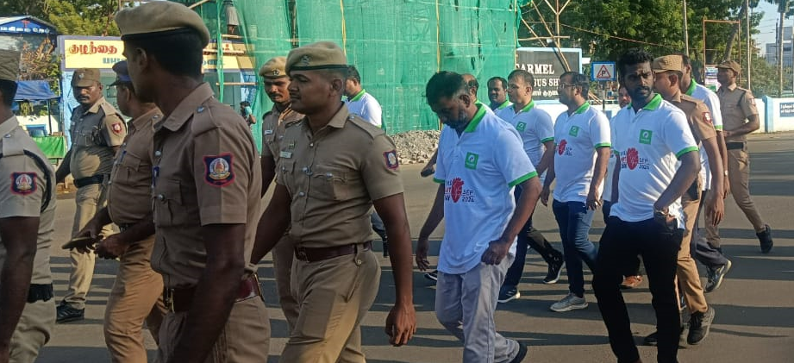

**Our University Staff members and NSS Volunteers actively participated the Walkathan.**

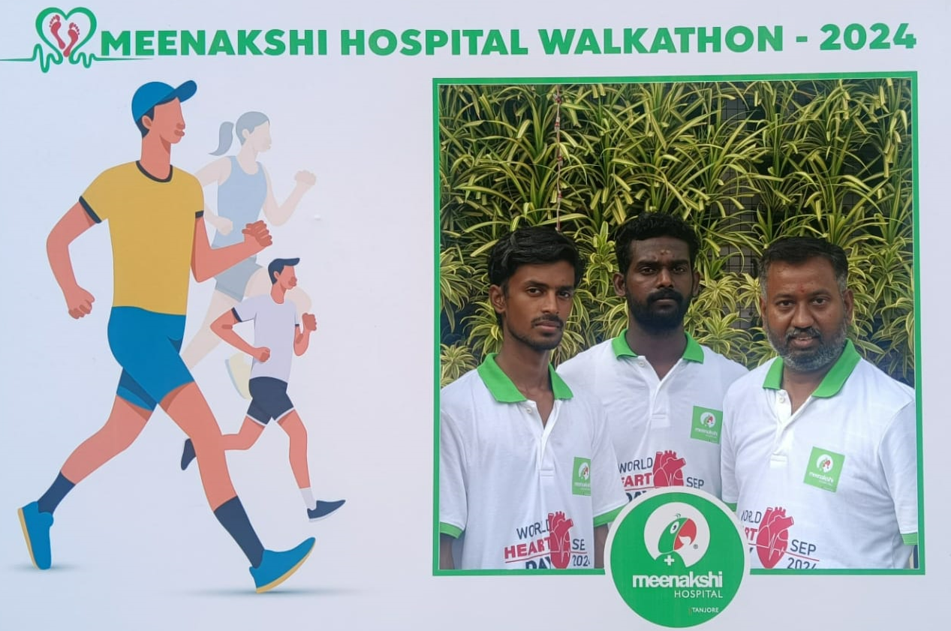

**Glimpses of walkathon photo point.**

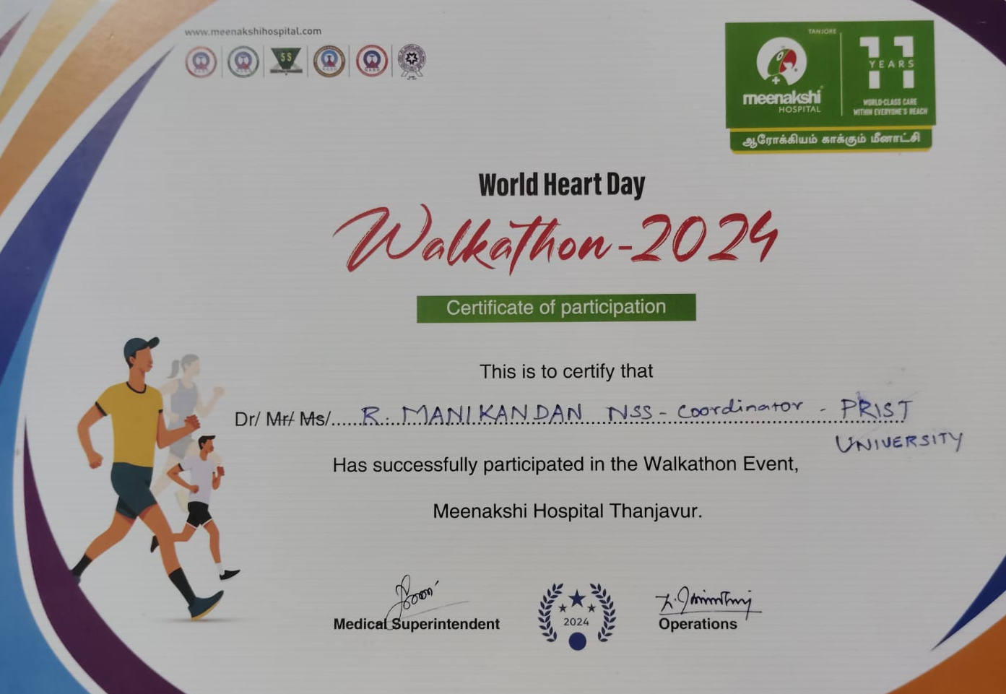

**Sample Certificate – that of Coordinator, NSS.**